Project Description

***Internship 2020 (Verzeo)***

Problem Statement: - (as given over the E-Mail)

Voice controlled robot using Arduino / Application Controlled

Robot should be controlled by the given voice commands from the phone. The voice is transferred from the mobile phone application to the Bluetooth module connected to the Arduino. Based on the commands for ex: If we say “10 forward” the robot should move 10 centimetres forward.

Project Description: - The Project objective is to make a Voice Controlled Robot that can be controlled by an app on the Android Platform. The Voice is converted into text by Google voice-to-text technology. The app sends the ‘text’ to the Arduino board using BT module, which is processed by Arduino board and results in Motion of the Robot.

**Note: -Full Codes can be found in Codes Folder**

App links: - BT Controller: -

<https://play.google.com/store/apps/details?id=com.helektrika.bluecontrol&hl=en_IN>

Voice control App: -

<https://play.google.com/store/apps/details?id=appinventor.ai_cempehlivan92.Arduino_Sesli_Kontrol>

Equipment required: - (as given on the mail)

1. Arduino UNO with cable

2. Bluetooth HC-05

3. L293D motor driver

4. Two-wheel robot chassis

5. Two dc motors

6. jumper wires

7. Mini breadboard

8. 9v battery (power bank)

9. 2 Battery clip connectors (1 connector must be suitable with dc jack on Arduino)

10. Speed sensor with encoder wheel

**Simulation Diagram**: -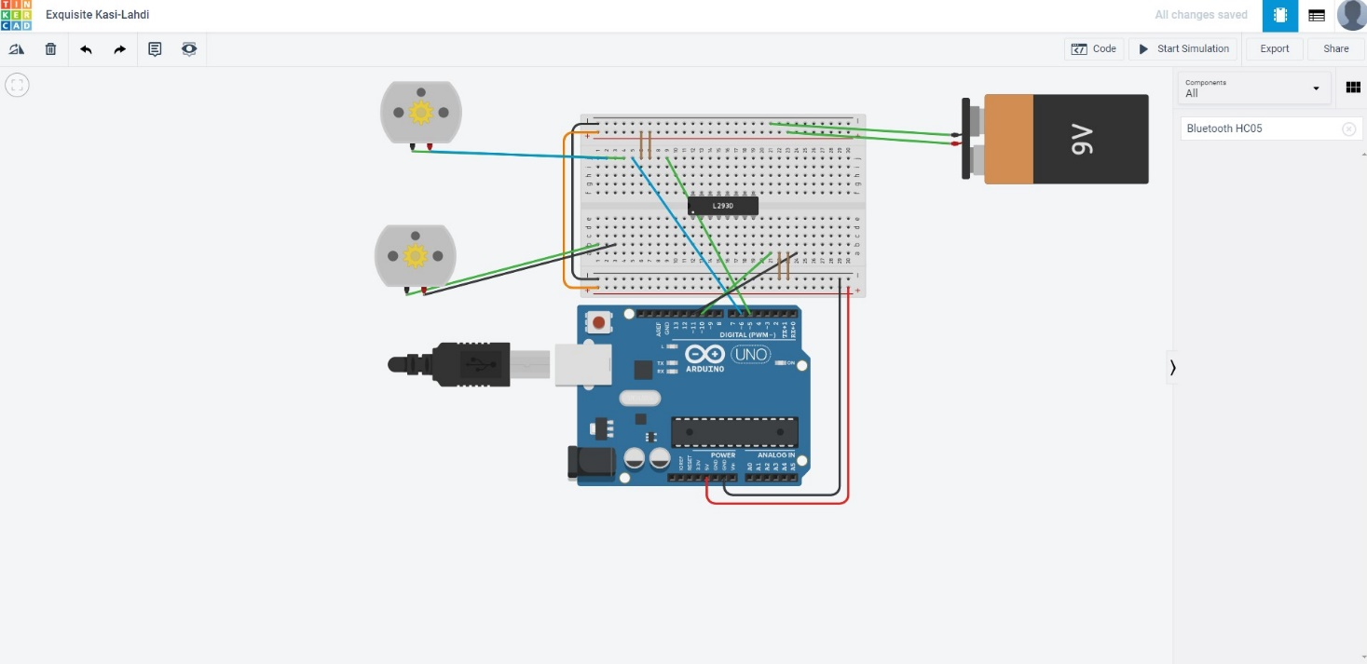

**Since, HC-05 BT device was not available on tinkercad, Simulation is incomplete.**

**Link of Tinkercad: -** <https://www.tinkercad.com/dashboard>

**Flowchart of the project:** -

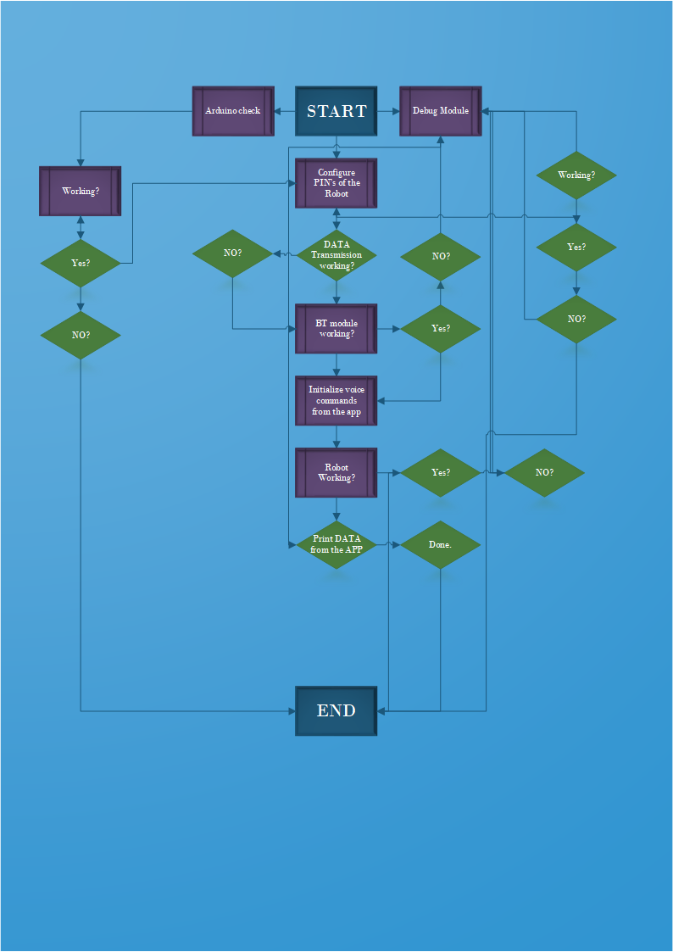

**Code(s) Description:** -

**Note: -Full Codes in Codes Folder**

1.Working of *BT Module (for testing):* **This code tries to establish a connection with BT module (HC-05) with the help of Arduino**. The BT device is connected on 8th pin of Arduino Board. After confirming BT data transfer, the code initializes Data transfer from app to the Arduino. (app link above)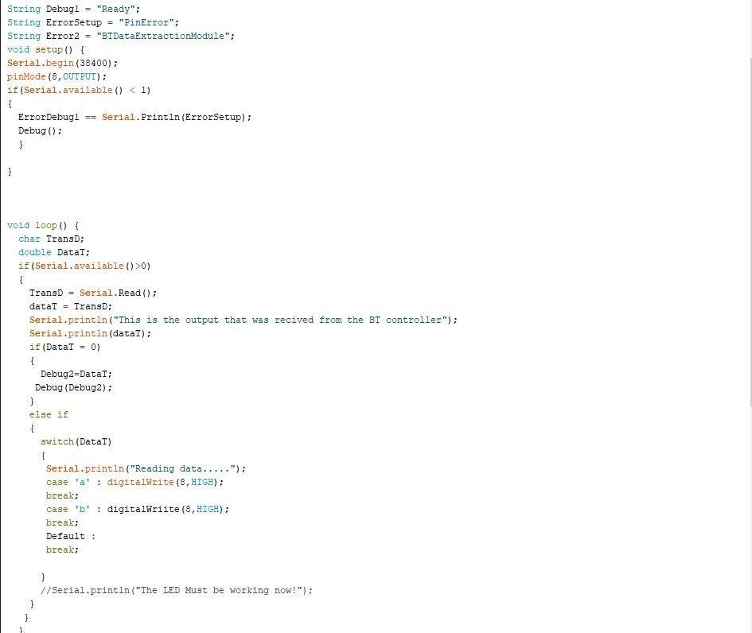

If Errors are found, in the BT connection Module, debug function tries to Debug it.

**How to connect your BT device with Android Device?**

* When you are connecting to the Bluetooth module for the first time, it will ask you the password. **Enter 0000 OR 1234**.
* When the device gets successfully paired with the sensor, Run the code **Above.**

Working of Voice Controller Module-

**This code assumes that you have established a BT connection with Arduino board.**

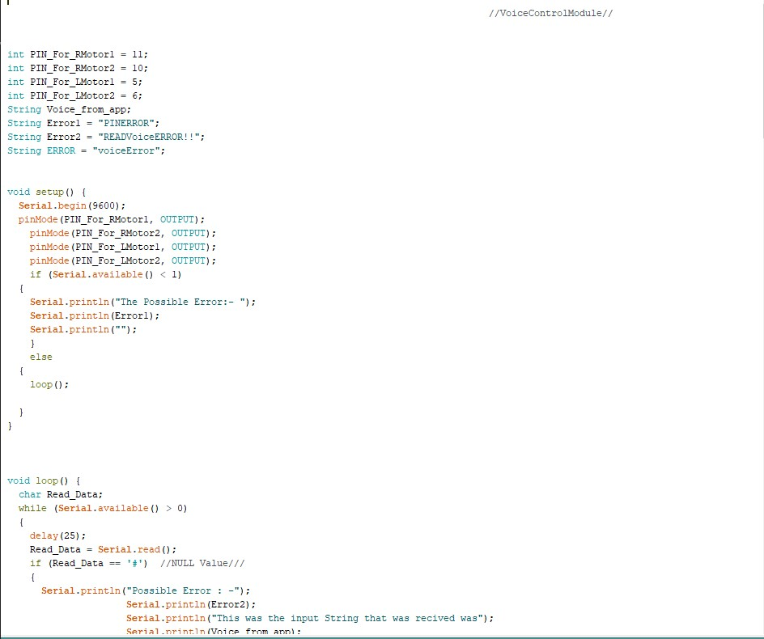

**When connection is established between app and the ROBOT (motors)**, the code tries to initialize motion of the Robot by Logic values of the Left and Right Motors (with PIN no’s): -

|  |  |  |
| --- | --- | --- |
| **ACTION** | Configuration for RM1 and RM2(11,10) | Configuration for LM1 and LM2(5,6) |
| Forward | LOW, HIGH | Low, HIGH |
| Reverse | HIGH, LOW | HIGH, LOW |
| Left | LOW, HIGH | HIGH, LOW |
| Right | HIGH, LOW | LOW, HIGH |
| STOP | LOW, LOW | LOW, LOW |

If the Voice is not found/recognized by the app, the Code tries to debug it BT controller Module.